PRESS RELEASE FOR PUBLICATION
Leonberg, 13 October 2016

Brigitte Vöster-Alber awarded “Prize for Social Market Economy”
by the Konrad-Adenauer-Stiftung

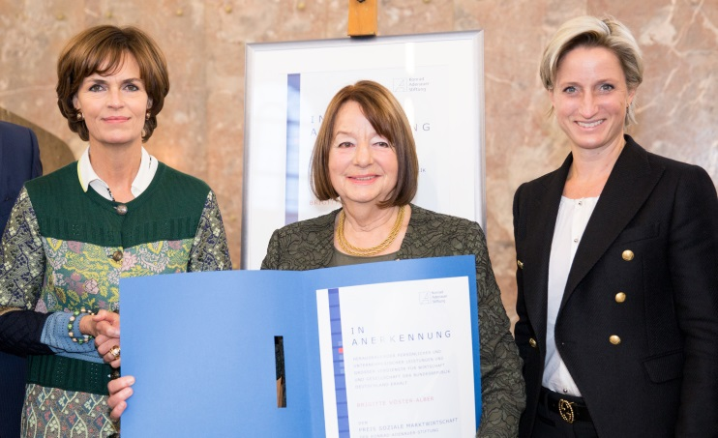
The Konrad-Adenauer-Stiftung Prize for Social Market Economy being presented by the Chairman of the jury, Dr Nicola Leibinger-Kammüller, and the Minister for Economics, Labour and Residential Construction in Baden-Württemberg, Dr Nicole Hoffmeister-Kraut, photo: KAS/Liebers

The foundation Konrad-Adenauer-Stiftung honours Brigitte Vöster-Alber, Chief Executive Officer of GEZE, with the Prize for Social Market Economy 2016. “She is the driving force behind the goals of the family business, and the guardian of its values. She is also a fine example for entrepreneurial vision, the capacity for innovation, and a high level of responsibility towards the company’s employees, but also towards society and the environment”, the jury said in its statement. There could be no worthier setting than a ceremony with around 300 guests plus minister Nicole Hoffmeister-Kraut, Frankfurt’s former Mayor Petra Roth, and councillor Bernd Heidenreich held in Frankfurt's St. Paul's Church, where Brigitte Vöster-Alber became the 14th recipient of the award on 13 October 2016.

The principles underlying the Social Market Economy are reflected in Brigitte Vöster-Alber's leadership style. She started out in business in 1968 when, at the age of just 24, she accepted a huge responsibility when she took over from her grandfather Reinhold Vöster as Chair of the Board. She continued to further develop his social set of values.

One step ahead of the future
Her priorities are to think and act with a view to the long-term, organic growth and the fundamental principle of long-term, sustainable revenue rather than the short-term maximisation of profits. Employee numbers have been increasing for years, with a workforce of almost 2,800 today. The high equity ratio ensures the company's independence. It enabled GEZE to survive the 2008 financial and economic crisis, and even to make anti-cyclical investments which are paying off today. In 2009, GEZE itself invested close to 30 million euro in expansion activities abroad. Internationalisation as one of the cornerstones of the corporate strategy, 31 subsidiaries, 27 of them abroad, and manufacturing facilities in China and Eastern Europe strengthen the sites in Germany. Although operating globally, Brigitte Vöster-Alber is committed to Germany as its primary development and production location. Since 2010, GEZE has invested around 24 million euro in erecting and expanding buildings, the most up-to-date technological facilities available, and manufacturing and logistics systems at its headquarters in Leonberg. A new production facility was commissioned in 2015. The completion of a development centre in 2017 will create the environment for further innovations and new products that will define the future, and create new and attractive jobs.

Attractive jobs – the power of innovation as a corporate principle
In recognition of its innovation management, GEZE this year won the prestigious 'Top 100' award for the seventh time and can now call itself one of the most innovative companies in Germany. With its premium products, GEZE is one of the global market leaders in door, window and safety technology. With its innovative solutions, GEZE is anticipating market demands for increased comfort and safety in building technology. Maximum benefits, universal design, multi-functionality, networkability and operation via the internet will define the doors and windows of the future. The latest innovations are interface modules for networking GEZE products and systems in a 'Smart Building'. The latest awards, such as the PROTECTOR Award for safety technology in Silver for the new IQ box KNX interface solution confirm the significance of these innovations.

GEZE was once again awarded the 'Top Employer Germany' and 'Top Employer for Engineers' awards for its excellent personnel management. Employees are encouraged individually, because it is the most qualified specialists and managers who will really make the difference in a highly specialist technology company. GEZE offers training positions and dual study opportunities across a range of fields, as well as attractive development prospects for trainees, young professionals and experienced practitioners. GEZE is particularly proud to belong to the category of employers that are the most in demand, including as far as engineers are concerned. Targeted investment in their development ensures systematic 'real life' innovation management, and gives them the free scope that is particularly important to product development processes. Supporting well-qualified staff and balancing work and family with individual working models and home office employment opportunities are firmly anchored within the HR policy. At 28 %, the current proportion of women in management and other positions is exceptionally high, and has increased by around a half in recent years.

Corporate Social Responsibility
Within GEZE, Brigitte Vöster-Alber has created a tradition over the decades from what is now associated with this modern term. Its social commitments range from financially supporting medical, social and cultural educational facilities through to spontaneous aid campaigns. GEZE has for many years been supporting the Olgäle-Stiftung für das kranke Kind e.V. [Olgäle Foundation for Sick Children]. Its six-figure financial donations benefit the new and highly specialist Olgahospital children's clinic in Stuttgart. In 2013, the year in which the company celebrated its 150th anniversary, it also started to support the child welfare agency Plan International Deutschland with 150 sponsorships. A child is added each year, so now 153 children are benefiting from GEZE's assistance. In 2009, Brigitte Vöster-Alber was awarded the Order of Merit of the Federal Republic of Germany for her exceptional commitment as a businesswoman.
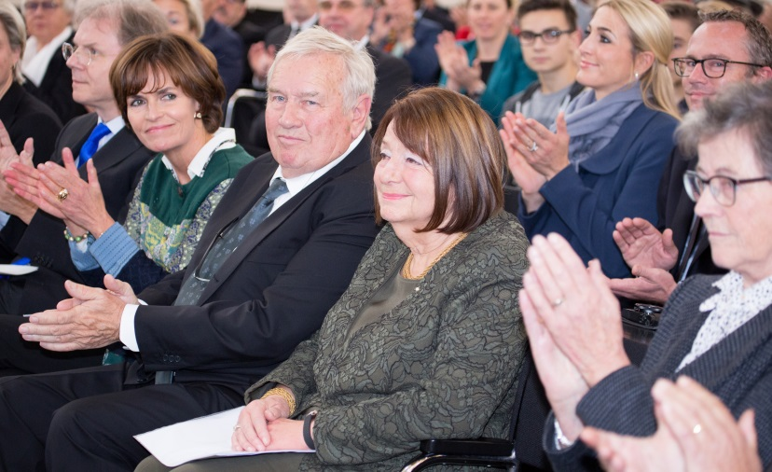
The happy award-winner Brigitte Vöster-Alber with her husband and long-serving Managing Director for Technology Hermann Alber, together with the jury. Photo: KAS/Liebers

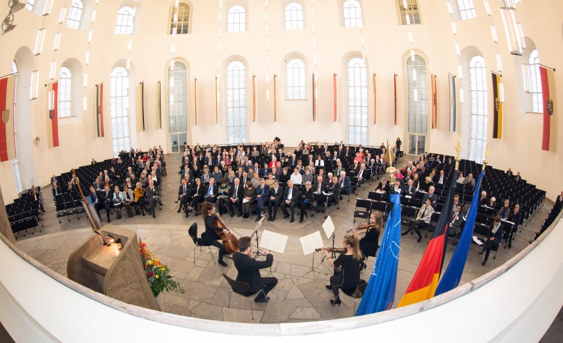
The St. Paul's Church provides a fitting setting for the awards ceremony, with the democratic spirit of 1848 shining through.
Photo: KAS/Liebers

