PRESS RELEASE FOR PUBLICATION

Leonberg, 26 June 2017

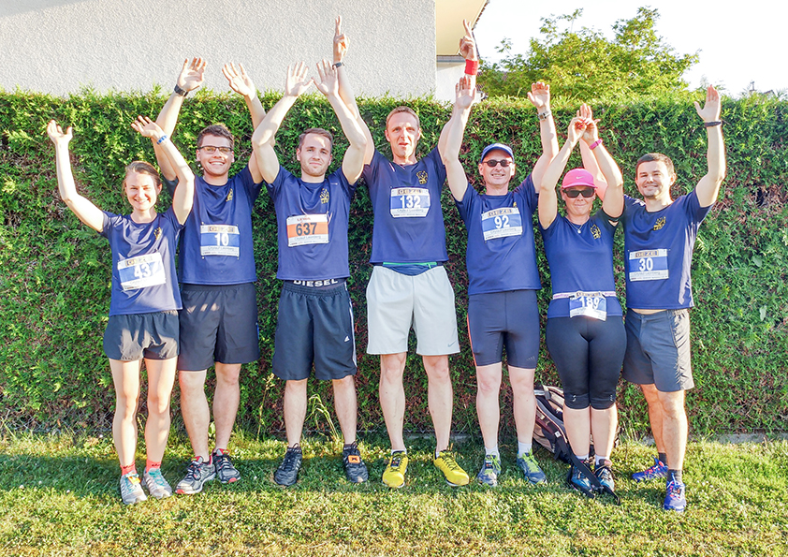
Photo: GEZE GmbH

GEZE supports 8th Leonberger Citylauf
10 kilometre run for good causes

For the eighth time in succession, the Leonberger Citylauf (Leonberg City Run) was held on the last Saturday in June with more than 1,100 participants. The event offers different distances for all ages so there is something to suit all needs and levels. As the main sponsor, GEZE GmbH supports the longest route – the 10 kilometre run. The varied course, which takes participants through Leonberg’s old town, among other places, requires only few climbs from the runners and offers perfect conditions for top speeds. This year, the run took part in perfect running weather and great atmosphere and the GEZE team even supplied the female winner of the 10 km.

"As a Leonberg company, we are delighted to support this event. We just love the excitement of taking part and of course we are really chuffed about one of the GEZE runners winning the 10 km run,”beams GEZE CEO Brigitte Voster-Alber.

Social commitment – particularly for the society's weakest – has always been a key issue within GEZE. Its activities also include support for local, regional and national sporting events. The proceeds are used for socio-medical and cultural purposes, or to support educational institutions. Once the proceeds of this year's GEZE 10 km run are known, the company will decide jointly with the City Run organisers how the money is to be used.

