PRESS RELEASE FOR PUBLICATION

Leonberg, 03 April 2017

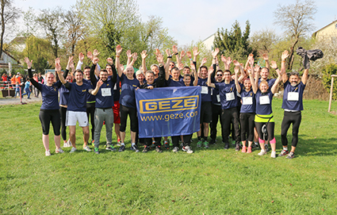

GEZE supported the 'Ditzinger Lebenslauf' race for the tenth consecutive time in 2017.

GEZE supports 'Ditzinger Lebenslauf' race 2017:

A decade of sponsorship - and one of the biggest groups of runners

GEZE took part in the charity run for cystic fibrosis sufferers for the tenth time in succession. The GEZE LEO team was one of the largest groups of participants again this year. 63 runners “went the distance,” covering 1,008 kilometres and raising a total of 2,420 euros, which corporate management rounded up to 3,000 euros.

The moderator of the event sounded the starting signal for the group of runners of the GEZE LEO team, which was composed of staff from all corporate areas, supported by their families and friends. This year, a total of 63 runners took part, covering 1,008 kilometres. Each kilometre will be converted into a donation, helping to support projects to improve cystic fibrosis treatments and research, and gain even more public awareness for this still incurable metabolic disorder.

“The Ditzinger Lebenslauf race is a key component of our commitment to medical and social issues. We are happy that so many staff members take part with so much enthusiasm, getting involved for a good cause. For years GEZE has also supported the Olgäle foundation for sick children (Olgäle-Stiftung für das kranke Kind e.V.) in Stuttgart. In cooperation with the children's relief organisation Plan International, GEZE maintains over 150 sponsorships for children and young people in the poorest regions of the world,” says Gabi Bauer, head of the International Marketing department.

Press contact:  Julia Graf  Tel.: +49 (0) 7152 203-505  j.graf@geze.com  Fax: +49 (0) 7152 203-237 | GEZE GmbH  Reinhold-Vöster-Str. 21-29  D-71229 Leonberg  www.geze.com

About GEZE
The GEZE brand stands for innovation and for top quality products, processes and services. GEZE is one of the leaders in the global market and it is a reliable partner worldwide for door, window and safety technology products and systems. No matter what the requirements of a building are – GEZE implements optimum solutions and combines functionality and security with comfort and design. GEZE door closers open up numerous technical and visual possibilities. Every day, millions of people go through doors equipped with the overhead door closers from the TS 5000 series and enjoy the comfort of automatic door systems, e.g. the Slimdrive range. Barrier free door and window systems provide greater comfort, not only for people with restricted mobility. The glass systems and fitting solutions for the attractively designed sliding systems are the ultimate in design aesthetics. GEZE also offers a wide product range in the field of window and ventilation technology. Complete "intelligent" smoke and heat extraction solutions (RWA) and a comprehensive selection of door systems for RWA air supply solutions are also available for preventive fire protection. GEZE's safety technology includes escape and rescue route solutions, lock technology, and access control systems. The GEZE building management system provides an overview of a building's entire technical facilities. With its systems expertise, GEZE creates coordinated system solutions which combine individual functional and safety requirements in one intelligent system. GEZE product solutions have received numerous awards and can be found in renowned structures all over the world. The company has a global presence with 31 subsidiaries, 27 of which are outside Germany, a flexible and highly efficient sales and service network, and almost 2,700 employees. In the 2014/2015 fiscal year, GEZE achieved a turnover of over 366 million euros. www.geze.com

